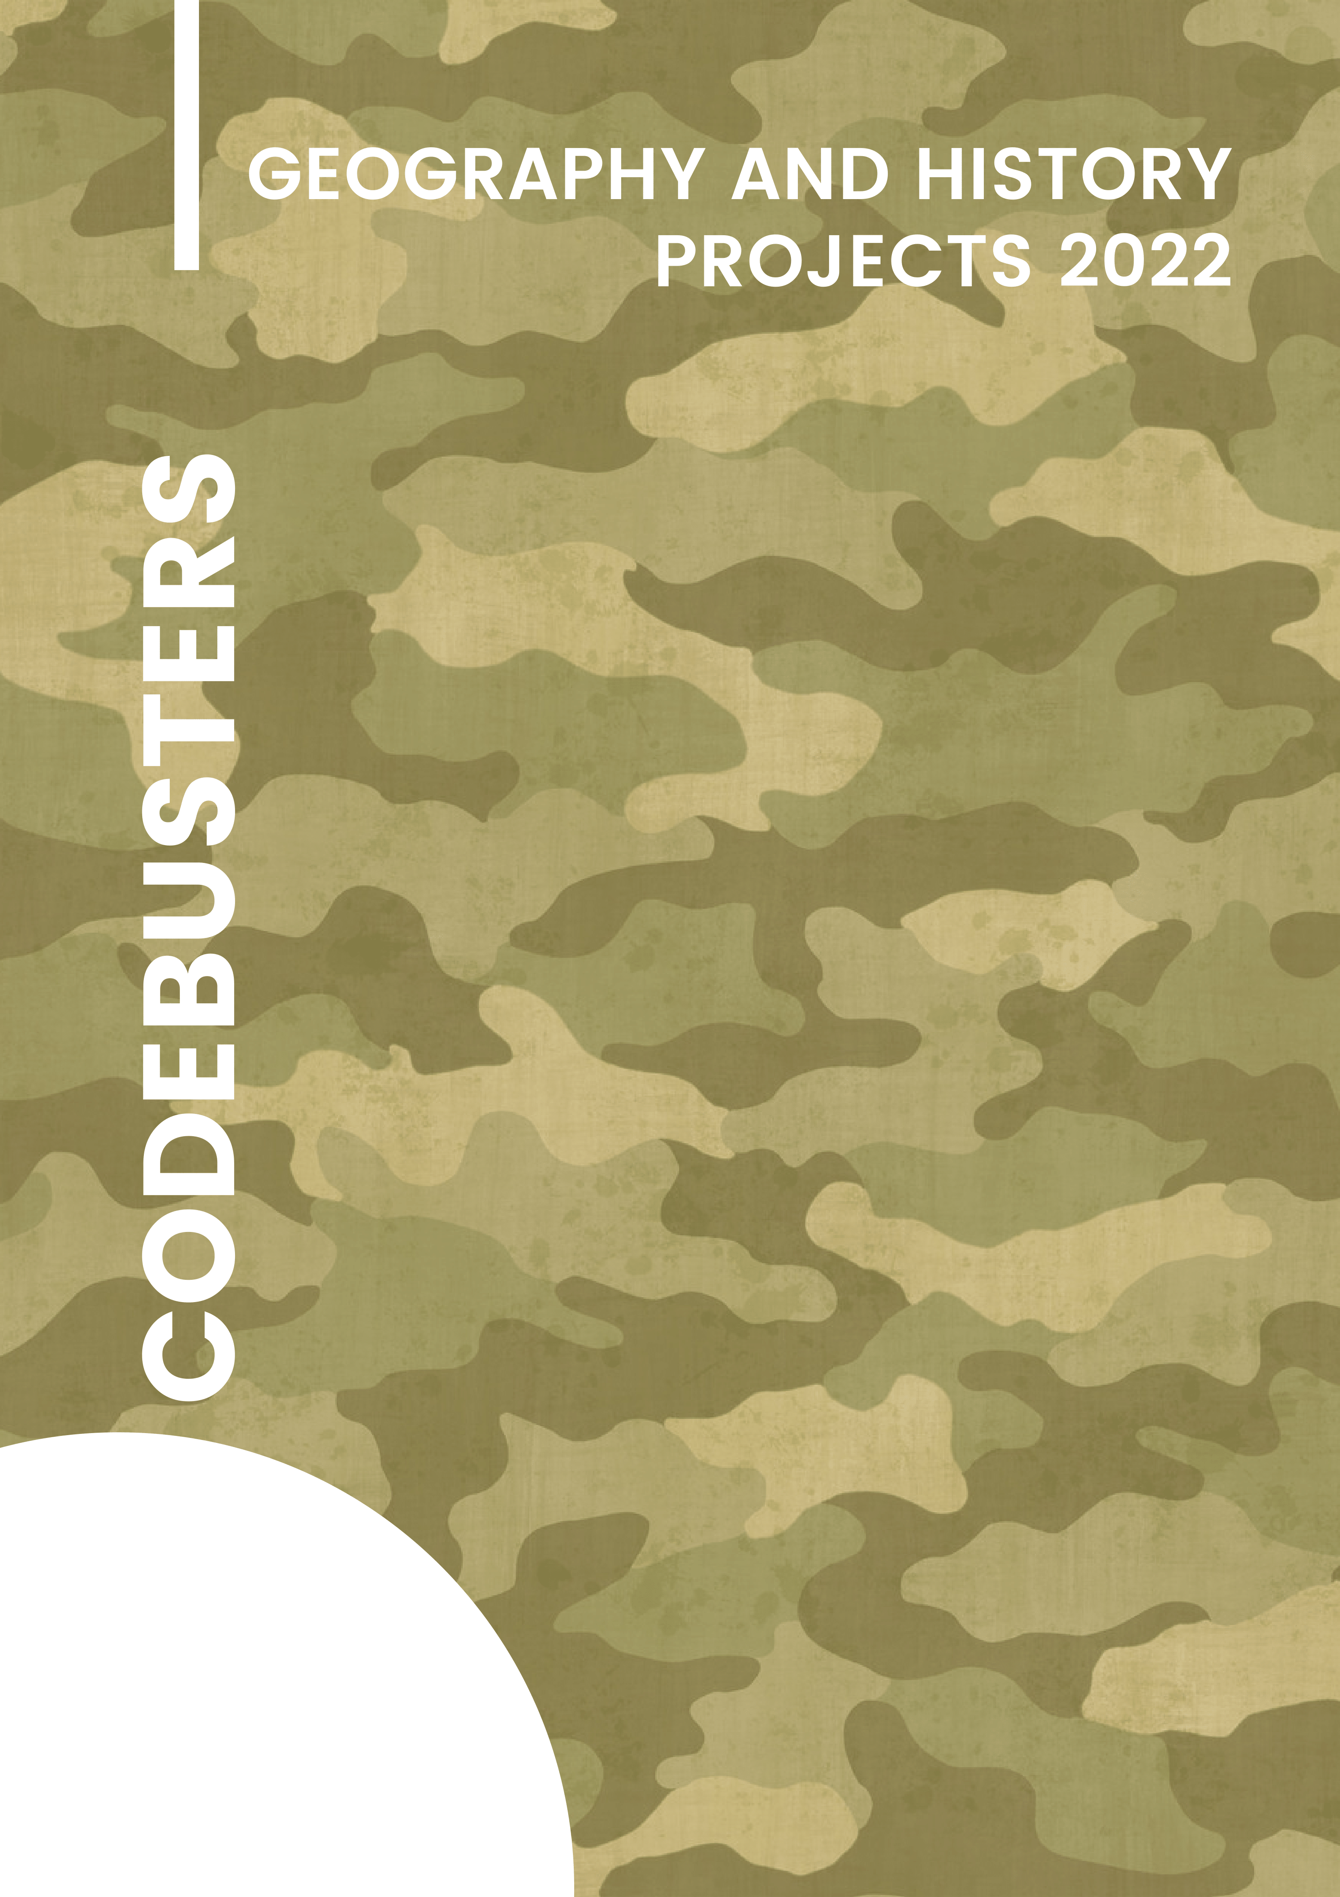

Contents

1. Project theme 2
2. Team 2
   1. Iliyana Michevska 9A – Developer Front-end 2
   2. Vanesa Kardzheva 9A – Developer Back-end 2
   3. Elena Keserzhieva 9A – Designer 2
   4. Elina Genova 9A – Scrum trainer 2
3. Resume 2
   1. Goals 2
   2. Stages of realization 2
   3. Realization 2
   4. Site 2
   5. Quiz game 2
   6. War game 2
4. Conclusion 2
   1. Solutions 2
   2. Future ideas 2
5. **Theme of the project**

The theme of our project is the historical and geographical implications of World War One. We wanted to focus on sharing useful information about this important but tragic war.

1. **Team**
   1. Iliyana Michevska 9A – Developer Front-end
   2. Vanesa Kardzheva 9A – Developer Back-end
   3. Elena Keserzhieva 9A – Designer
   4. Elina Genova 9A – Scrum trainer
2. **Resume**
   1. **Goals**

One of our main was creating an informational site with which the user can learn new things about World War One. We did that in an interactive unique way - a folder which shows 3 sections, changing pictures about fronts and a digital letter replica. The site also has a custom scrollbar and cursor.

Besides the site, we also made a quiz game with which the user can test their knowledge. The game has a 2-player mode and custom assets made by us.

We also have a World War One themed shooter game. The user plays as Germany – the user plays by shooting opponents with a weapon.

* 1. **Stages of realization**
     1. Beginning

First, we formed our team, assigned the roles and organized our meeting schedule. Afterwards we discussed our ideas, combined them and got ready to start working.

* + 1. Planning

We started our work using Discord and Teams as communication platforms. We discussed ideas, gave many different suggestions and shared how each of us sees the final product, came to a consensus and started working. We allocated our tasks, each performing their assigned tasks on time.

* + 1. Changes

After writing the whole code, we tested it multiple times and fixed some errors.

* 1. **Realization**
     1. **Used technologies**
        1. Color scheme

#051b0a

#e9c69c

#dab784

#212120

#121313

* + - 1. Fonts

We used [google fonts](https://fonts.google.com/)' font for the main page and our personal custom font for the letter.

* + - 1. Technologies:

1. HTML5
2. CSS3
3. JavaScript
4. GitHub
5. Discord
6. Teams
7. VS Code
8. Google Fonts
9. Draw.io
10. Canva
    * 1. **Sources:**
11. <https://www.history.com/topics/world-war-i/world-war-i-history>
12. <https://www.history.com/topics/world-war-i/world-war-i-history>
13. <https://www.standard.co.uk/hp/front/battle-of-amiens-facts-ww1-battle-a3905921.html>
14. <https://www.standard.co.uk/hp/front/battle-of-amiens-facts-ww1-battle-a3905921.html>
15. <https://www.panmacmillan.com/blogs/history/how-has-the-world-changed-first-world-war-ww1>
16. <https://www.forces.net/news/ww1-why-did-britain-join-first-world-war>
17. <https://cloudinary.com/>
18. <https://slidesgo.com/>
19. <https://fonts.google.com/>
20. <https://www.canva.com/>
    1. Graphical user interface, diagram

       Description automatically generated **Site**
    2. **Quiz game**

* 1. 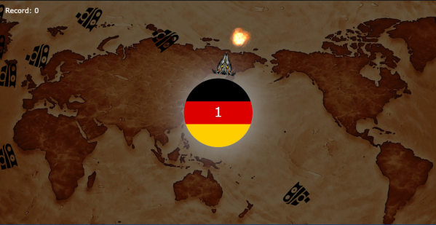**War game**

1. **Conclusion**
   1. **Solutions**

We have created an interactive informational site which teaches users facts about WW1, a Quiz game which helps users test their knowledge helping them memorize it better in a fun interactive way and a War game which provides entertainment.

* 1. **Future ideas**

We will be working hard to improve products. We are looking forward to make our product better by making it more accessible, adding more functions, cover more topics and last but not least make it even more entertaining.